FIRST PRIZE WINNER MR.HARAGOPAL’S SOLUTION

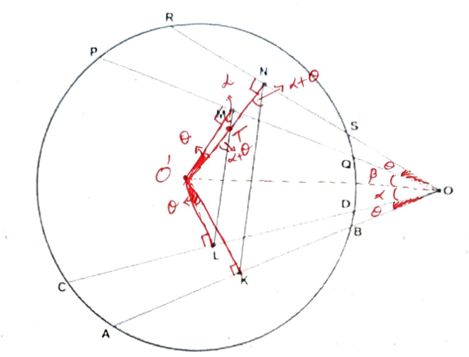
Given:
$∠AOC=∠POR,$ L, M, N, K are midpoints
To prove: LM$∥$KN
Construction:
Let $O^{'}$ be the center of circle and join it with the points L, M, N, K. Join $O^{'}O$
Proof:
Let $∠AOC=∠POR= θ$ &
$$∠O^{'}OL= α \& ∠O^{'}OM= β$$
As $O^{'}$is the center and L, M, N, K are midpoints of chords then
$∠O^{'}LD=∠O^{'}KB=∠O^{'}MQ=∠O^{'}NS=90°$[from the theorems of circles from class 9th $⊥$bisector of any chord passes through center (or) $⊥$ from center to chord bisects it]
Now as $∠O^{'}MO=∠O^{'}NO=90°$ and as they are same segment angles.
$⟹∠NOM=∠NO^{'}M= θ$ [ same segment angles are equal] ---- (1)
Similarly as $=∠O^{'}LO= ∠O^{'}KO=90°$ and as they are same segment angles.
$∴O^{'}LKO$ are cyclic
$⟹$ $∠KOL= ∠KO^{'}L= θ$ [Same segment angles are equal] --------------- (2)
And in quadrilateral $O^{'}NOK$
as $∠N+ ∠K=90°+90°=180°$
$∴$ $O^{'}NOK$ is also cyclic [same segment angles] -------------------------------(3)
$⟹$ $∠KOO^{'}$ = $∠KNO^{'}$ = $α$ +$θ$
And in quadrilateral $O^{'}$MOL
as $∠M+∠L=90°+90°=180°$
$∴$ $O^{'}MOL$is also cyclic.
$⟹$ $∠LOO^{'}= ∠LMO^{'}$ [Same segment angles are equal]
Let the intersection of lines LM & $O^{'}N$ be the point "T"
Now in $∆$ $O^{'}MT$, $∠O^{'}TL$ is the exterior angle = $α$ +$θ$----------(5) [Exterior angle property of triangle]
Now for the lines LM & KN, $O^{'}N$ is the transversal and the angles.
$∠O^{'}TL$ & $∠O^{'}NK$ are corresponding angles as they both are equal to "$α$ +$θ"$
$∴$ LM$∥$KN
*******************

